9.1d

Hoglets Pre-school
Prospectus 2026

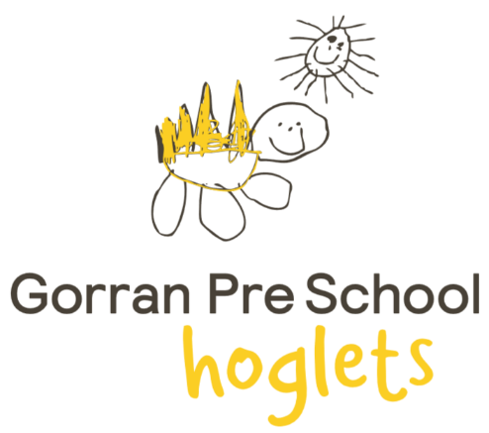

Welcome to Hoglets Pre-school

Our ethos of learning through play uses structured play activities to promote development. While playing and communicating, children are also socialising, learning about the world around them, numbers, shapes, space and developing their physical and creative skills. It is important to us that the children are always having fun through learning and thrive on being independent.

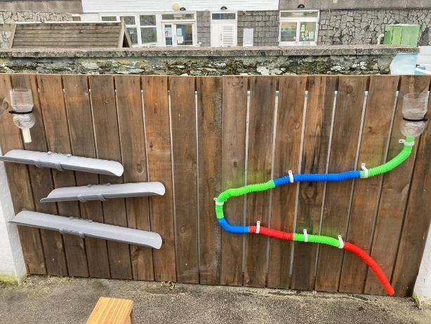
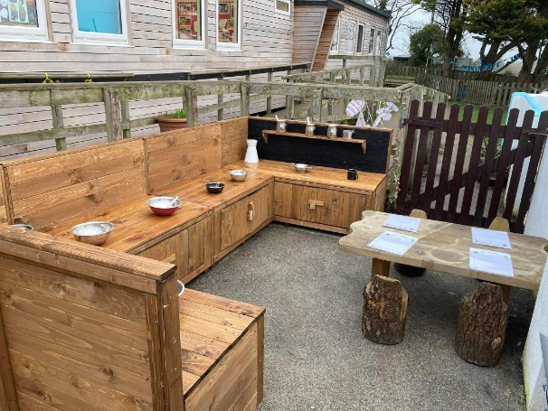

Contents
- Introduction
- Committee team
- Staff team
- Designated areas of responsibility
- How the preschool is organised
- Learning journals & the Early Years Foundation Stage
- Child centre theme based learning
- Recording achievement
- Parents as partners
- Starting preschool
- The preschool session
- Settling in suggestions
- The practicalities
- Admissions
- Fees
- FAQ’s 2
- Activity days with your child
- Equal opportunities
- Festivals
- Resources
1 – Introduction
Hoglets Pre-school is a registered charity run by a voluntary committee and was registered in 1977. We are located in the rural village of Gorran. We were given an overall effectiveness of GOOD by OFSTED in September 2025. We have a bright and spacious indoor room and an enclosed well equipped garden area. We aim to keep our indoor and outdoor spaces set up in similar ways to provide the children with equal opportunities indoors and outdoors. We have ongoing commitment to always be extending our staffs knowledge and experience by providing constant training to the latest approaches to preschool education.

Quotes from OFSTED:
“Children thrive in this warm and friendly pre-school.”
“Children build close bonds with staff and new children settle quickly.”
“Staff provide an ambitious and engaging curriculum that focuses on children developing important skills and attitudes, such as problem-solving, confidence and resilience in their learning.”
“Staff place a high priority on supporting children to develop their independence.”
“Partnerships with parents are strong.”
“Children are well prepared for the next stages in their learning, and transitions to school are a strength of the pre-school.
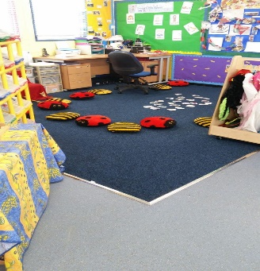
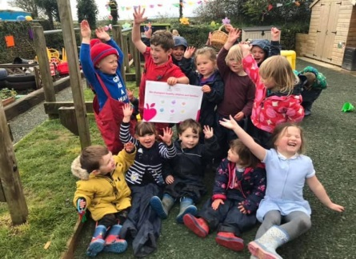
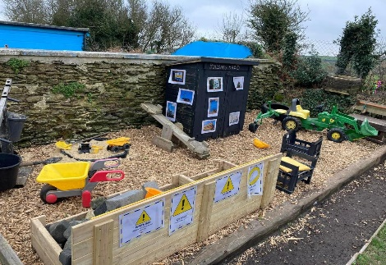

Our aims:
- To work within a single qualifying framework that supports children from birth to the end of the foundation stage in a parent-partnership community-based group.
- To provide a safe, secure, and stimulating environment where children can be independent.
- To work within a framework which ensures equality of opportunity for all children and families.
- To promote learning through play and experiences

We offer your child:
- A specially tailored curriculum leading to the Early Years Foundation Stage goals.
- Individual care and attention made possible by a good ratio of adults to children.
- Fun and friendship with children and other adults
- Opportunities for you and your family to be involved in same activities of the group and your own child’s progress through an online system called Tapestry.

2 – The committee team




Carolyn Fox
Chair
Danielle Johns
Secretary
Lesley Pothecary
Treasurer

3 – The staff team
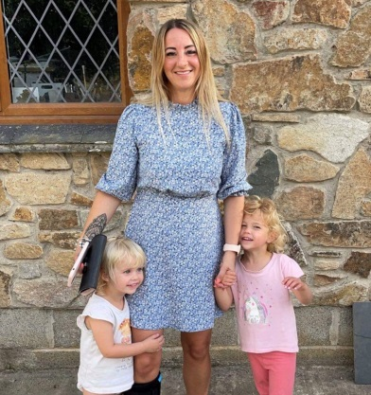
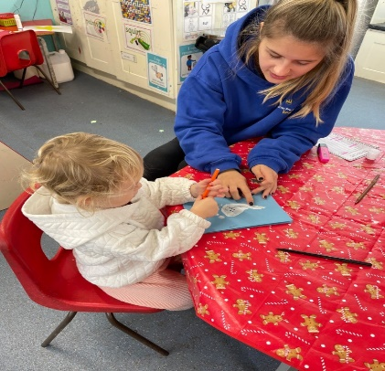
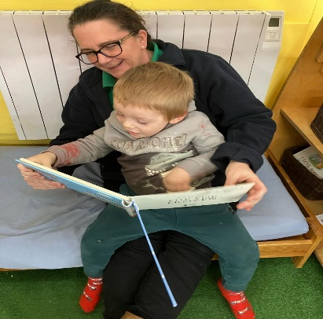

Michelle Floyd
Pre-school assistant
First Aid
Food Hygiene
Safe Guarding

Aimee Dedman
Deputy Manager
SENDCO Lead
Healthy eating co-ordinator
First Aid
Food Hygiene
Safe Guarding
Michelle Beard
Manager
Designated safeguarding Lead (DSL)
Behaviour management
First Aid
Food Hygiene
Safe Guarding

4 –Designated Special Educational Needs Co-Ordinator: Aimee Dedman

Behaviour Management: Michelle Beard

Safeguarding Officers: Victoria Wright & Michelle Beard

Equal Opportunities: Michelle Beard

Each child is allocated a member of staff as their key worker. Your child’s key worker, along with all the staff members, is responsible for monitoring and recording your child’s progress and development while they attend the preschool setting.
Please note: ALL staff members are DBS-checked, and First Aid trained for your children’s protection.

5 – How the preschool is organised

The preschool is registered with the Office for Standards in Education (OFSTED). Our registration number is: 509092. All reports are available for inspection and can be found online or given to you by request.
The preschool is affiliated with the Early Years Alliance (EYA).
The preschool is a charity organisation run by an elected committee, which is responsible for reviewing practice and for the employment and appraisal of members of staff. The management committee is made up of professionals and parents who work together to run our charity run Preschool. We have a chairperson, treasurer, secretary and committee members. The manager also sits on the committee so we have continuity throughout the setting. The fundraising committee is relaxed and friendly and provides the opportunity to make new acquaintances. We would like to have fundraising each year to raise funds for our preschool. At times it can be hard work, but it is also rewarding fun. Please feel free to contact any current committee members for an informal chat. A list of names and telephone numbers is displayed on the foyer notice board as well as above.
The Annual General Meeting is held in the spring when committee is elected. All parents are encouraged to attend and hopefully to become involved with the preschool in some way.

Fundraising
Fundraising is essential to the preschool; fees cover only the basics such as wages and expenses. Fundraising is needed to provide equipment and materials along with outings and the children’s Christmas party. We have a dedicated fundraising section within the main committee, which organises various events to raise money for the preschool. This year our fundraising efforts have provided kitchen equipment and we have been able to replace some well-loved toys. New members to the fundraising committee are always welcome.

Selecting the right pre-school for your child
Making the right choice of preschool depends upon many factors. Of course, you will consider the educational standards and practices of the school it is attached to, and an OFSTED report should be available upon request from preschool to aid comparison.
A prospectus shows the aims and objectives of the preschool, explains more fully the Early Years Foundation Stage requirements and provides all the necessary staffing and daily information you require.
A policy document will assist in understanding the principles that underline the daily work of the preschool.
You will also have your child’s personality very much in mind and how your child as an individual will fit in to our learning and play environment.

6 – Learning journals and the Early Years Foundation Stage (EYFS)

Within the group, all children are supported in developing their potential at their own pace. Our system enables a planned curriculum tailored to the needs of each individual child. For our children we follow the EYFS framework. By means of developmentally appropriate play activities and a high level of individual adult input, we offer a curriculum that leads to the six nationally approved EYFS goals and prepares children to progress with confidence to the National Curriculum.
Your child’s Learning Journal celebrates his or her experiences. Over time it will tell a story about your child, his or hers learning, friends and the experiences he or she enjoys sharing with others.
Staff watch and notice each child at play because it helps us to understand and support the individual’s well-being and development. We really get to know the children as unique people with special skills, interests, and ideas. The more we understand your child, the better we can support them in the way that is right for them.
The staff at Hoglets as well as parents and carers work together to build this learning journal as a record of your child’s Early years. We value parents and carers using Tapestry online to share their child’s learning. Throughout the year you can contribute to your child’s journey through Tapestry.
At this age so much happens so quickly and we would love to hear about events, activities and achievements which can be put on Tapestry. We would
Your child’s creations – these could be photos of models, photos of their role play, marks they have made, or art-making with an observation to explain what your child did or said.

Learning stories or detailed observations – these detailed observations give snapshots of learning that your child has initiated themselves. Staff then think about what and how your child is leaning, their development and how best to support them further.
Photographs – these capture moments and sequences of your child’s experiences, their interests and explorations. You can add some of your own from home to their learning journals. Sometimes, we will write down exactly what your child says about the photographs, so we know your child’s point of view. This is an accurate record of language development. Pictures of important people and things from home will help your child to feel secure when making the link between home and their educational setting.

love to see photos uploaded so see what they get up to.
Observations – these are quick notes of significant moments we notice in your child’s learning.

Every child’s Tapestry Learning Journal will include the following:
Amongst all the notes and observations you may see reference to areas of the Early Years Curriculum known as Early Years Foundation Stage (EYFS) which supports children from birth to the end of their reception year at school. The government and early years professionals use the abbreviation EYFS. This is a very important stage as it helps your child get ready for school and it is a legal requirement.

A Unique Child | Positive Relationships | Enabling Environments | Learning & Development
Every child is a competent learner from birth who can be resilient, capable, confident and self-assured. | Children learn to be strong and independent from a base of loving and secure relationships with parents and/ or a key person. | The environment plays a key role in supporting and extending children’s development and learning. | Children develop and learn in different ways and at different rates and all areas of Learning and Development are equally important and inter-connected.

This curriculum is planned around four main themes:
3 prime areas
Personal, Social & Emotional Development (PSED) | Communication & Language (C&L) | Physical Development (PD)

4 specific areas
Literacy (L) | Mathematics (M) | Understanding the World (UtW) | Expressive Arts and Design (EAD)

Alongside the seven areas of development, there are also the Characteristics of Effective Learning which describe how your child learns best.
The 3 Characteristics of Effective Learning are:
- Playing and Exploring – Engagement – Finding out and exploring, playing with what they know and being willing to ‘have a go’.
- Active Learning – Motivation – Being involved and concentrating, keep trying, enjoying achieving what they set out to do.
- Creating and Thinking Critically – Thinking – Having their own ideas, making links choosing ways to do things.

Staff will refer to these areas of learning and characteristics when planning and preparing activities, and when assessing and observing your child. Adults will consider the Characteristics of Effective Learning within the observation, assessment, and planning cycle of the EYFS.

7 – Child centre theme-based learning

Our preschool runs on a structed principle. We have found through many years of experience that children respond and learn more easily when the session has a basic structure.
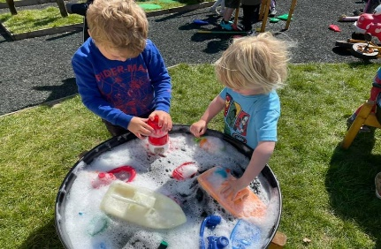
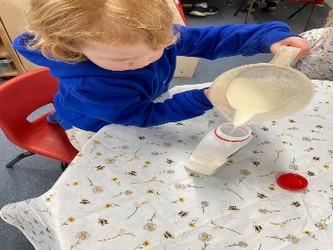
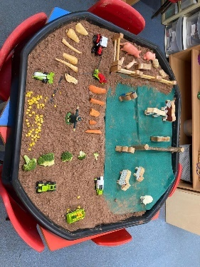
Throughout each half term the preschool has topics. These correspond to the Early Years Foundation Stage goals and the interests of the children which helps them to learn fundamental information.

8 – Recording Achievement

Keyworker system
A confidential record is kept for each child attending Hoglets Pre-school. Our records monitor your child’s progress working towards the EYFS goals.
Preliminary records monitor the settling in period and will mainly concentrate on Personal, Social and Emotional Development.
A key worker will be allocated to your child when they join the setting. As we are a small setting, we are very lucky to be able to get to know all the children who attend well.
All staff will be available to liaise with you and will welcome your suggestions for extending your child’s development. By observing children and working with parents we can tailor the groups curriculum to meet individual needs. You always have access to your child’s records. Please ask a staff member if you would like this.

9 – Parents as Partners

Parents Involvement Policy
Parents are children first and more enduring educators. The aim of the preschool is to work together with parents to have a positive impact on children’s development and learning.

We will:
- Make all the settings systems and policies available to parents via our website.
- Ensure that parents are informed about their child’s progress.
- Involve parents in shared record-keeping about their own child, either formally or informally.
- Ensure all parents are fully informed about meetings, conferences, workshops, and training.
- Welcome the contributions of parents.
- Make known to parents the systems for registering queries, complaints, or suggestions.
- Provide opportunities for parents to learn about the preschool curriculum and about young children’s learning in preschool and at home.

Our preschool aims to support parents and they are welcome and encouraged to:
- Assist in fundraising (to ensure that our resources are kept fully up to date)
- We welcome all adult family members onto our fundraising committee. This allows parents and carers to be involved in raising money.

Special Needs
The number of adults in the preschool enables us to provide individual attention for each child. Whilst most children will progress at their own rate in all areas of development, we acknowledge that some children will require extra help to ensure that their special needs are being met. If you feel that your child has any special needs at preschool, please talk to the staff and they will be happy to advise you.

Keeping us informed
Please remember to keep the preschool informed of any change of mobile number, email address or postal address so that we can ensure you are always kept up-to-date and fully informed of all the activities within the setting.

10 – Starting preschool

Settling into preschool: Policy and Practice
We want children to feel safe and happy in the absence of their parents, to recognise other adults as a source of authority, help and friendship and to be able to share with their parents afterwards the new learning experiences enjoyed in the preschool sessions.
In order to do this, we will:
- Offer tours of the setting for prospective families
- Offer new start home visits.
- Introduce flexible admission procedures, if appropriate, to meet the needs of individual families and children
- Reassure parents whose children seem to be taking a long time to settle into preschool.
- Encourage parents, where appropriate, to separate from their children for brief periods at first, gradually building up to longer absences.

First days
A child who is tense or unhappy will not be able to play or learn, so it is important for parents and staff to work together to help the child feel confident and secure in the setting. We will support you with a range of strategies to help your child to settle in.
Experience shows us that many children settle very quickly, even if they are upset on seeing their parent leave. We will contact you if your child becomes distressed but do feel free to ring preschool as often as you like to put your mind at rest. The Play Leader or the other staff members will be pleased to tell you how your child is getting on.

11 – The Pre-school session
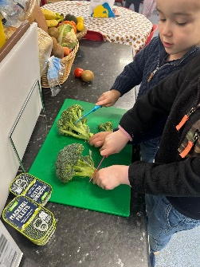
Preschool routine: Monday to Friday (term time)

8:45 – Arrive at preschool, greeted by a staff member at the gate.
9:00 – Registration, children sit on the carpet to do self-registration and group discussion about activities of the day.
9:15 – Free play including outdoor play (weather permitting) and a range of topical activities to promote Early Learning Goals
9:45-10:15 – Children to prepare their own snack and sit with friends to eat.
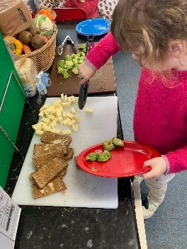
11:30 – Tidy up time.
11:40 – Story/nursery rhymes as a group on the carpet
11:45 – Home time for some children. Lunchtime begins.
1:15-3:00 – Free play including outdoor play (weather permitting) and a range of topical activities to promote Early Learning Goals
3:00 – Tidy up time.
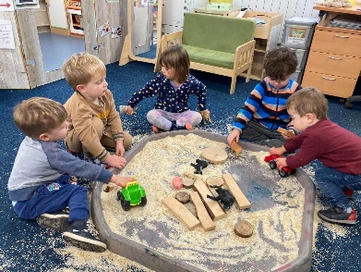
3:10 – Story/nursery rhymes as group on carpet
3:30 – Home time for all children

12- Settling in suggestions

Starting preschool is a big step for both you and your child. Some children may settle in very quickly whilst others may take longer. Circumstances vary considerably; for instance, some children may have an older sibling already attending and are desperate to join in the fun at 2 years old, whereas or others even starting at 3 years of age can be challenging.
The kind of approach each child needs will depend on their own unique personality; however, you may find the following tips useful in helping your child to settle in.
- Bring your child for a visit to preschool, tell them what to expect and show them children’s picture books on the subject.
- Give your child your full attention before becoming engaged in conversations with staff or other parents so that they have a chance to relax and familiarize themselves with the new surroundings.
- Let your child bring a favourite toy or blanket. Overtime we stop comforters coming into the setting in preparation for school.
- Gradually extend their time at preschool over several sessions.
- Encourage your child to talk about what they liked and disliked about the session so that you can support them in overcoming problems. Try not to show your frustration or disappointment if they are unhappy at first.

13 – The Practicalities

- Clothes should be either easily washable or not too new (so that your child can feel free to experiment with the messiest of materials) and easy to manage on trips to the toilet to encourage independence. A preschool polo shirt, jumper and fleece are available to purchase. Please ask the manager about these.
- Please ensure your child wears soft-soled shoes (plimsolls or trainers are perfect) as hard-soled shoes pose a danger to children. Only closed toe shoes should be worn. We ask for no sandals or crocs to be worn. We like to get outside as much as possible so wellies and waterproofs should be left at the setting and a coat should be bought in each session. During winter months we ask for hats and gloves and during summer months we ask for sunhats and suncream.
- Please do not send your child to preschool with any additional food as a variety of healthy snacks are provided during the sessions (unless special dietary requirements apply).
- If your child has had diarrhoea or vomiting, please do not send them into preschool for at least 48 hours after the illness has cleared.
- If someone else is to collect your child at the end of the session, please note their details in the Welcome Pack and let the staff members know by email or telephone.

14 – Admissions
Admissions policy
- The preschool is open Monday – Friday during term time only from 8:45-11:45, 11:45-1:15 and 1:15-3:30 and registers a maximum of 20 children per session.
- The preschool is accessible to children between ages of 2 – 4 years old to all families within the local community subject to availability. Admissions are through the year as soon as your child turns 2 years old. We will strive to meet the needs of families from all cultural, ethnic, religious, and social groups, with or without disabilities.
- Our waiting list is arranged in order of date of birth.
- An application form may be submitted at any time and children’s name will be added to the waiting list at the age of 2 years old.
- Should you wish to cancel a pre-booked session, you will need to give the preschool 1 months’ notice in writing.

Application Procedure
If you would like your child to join Hoglets Pre-School please complete an application form and return it to the preschool. Your child’s name will be added to the waiting list at the age of 2 and he/she will be offered a place subject to availability. You can ring the preschool to discuss your child’s needs and to arrange suitable sessions.
Please note that a non-refundable fee of £5 is charged termly to cover administration costs.

15 – Fees

We invoice termly in advance via email. Therefore, fees are payable each term within the first two weeks of returning to school. Fees continue to be payable if a child is absent, but in cases of prolonged absence, parents should discuss with the preschool manager.
Consumables fee – the funding we receive is unfortunately insufficient to cover our costs and we therefore charge a fee of £3.75 per day. This money is spent on consumables such as, snacks, outside activity groups, malleable materials, cooking ingredients and will go towards covering the cost of all other activities and resources we use to support your children in the setting.
1 term’s written notice is required before a child reduces sessions or stops attending Hoglets Pre-School. If a child should be withdrawn from attending preschool at short notice, the parent/carer will be required to pay for those sessions booked for that child until the end of the term.
We offer Universal government funding for eligible 2, 3 and 4 year olds. Children will become funded the term after they turn 3 years old. Your child will be funded for 15 hours per week. We are also able to offer up to 30 hrs Extended Funding to eligible families in receipt of the government eligibility code.
For our list of fees please see overleaf. A list of current fees is also available on our website.

Gorran Pre-School
Pricing 21st April 2025

Preschool
Age |  | Morning Session | Lunch Session | Afternoon Session | Full Day
 | Times | 8.45am – 11.45am | 11.45am – 1.15pm | 1.15pm – 3.30pm | 8.45am – 3.30pm
2 | £/hr | £7.55 | £7.55 | £7.55 | £50.97
2 | £/Session | £22.65 | £11.33 | £16.99 | £50.97
3+ | £/hr | £5.55 | £5.55 | £5.55 | £37.47
3+ | £/Session | £16.65 | £8.33 | £12.49 | £37.47
Other Fees
Consumables £3.75 per day.
Termly administration fee of £10.
A school dinner is available at an extra charge of £2.55.
Late payment fee of £30 per month.

Breakfast Club & After School Care
Breakfast Club  7.45am – 8.45am |  |  | After School Care  3.30pm – 6pm
2 year olds | £9 session |  | £6.50/hr
3+year olds | £7 session |  | £6.50/hr
Other Fees
1/2 termly admin £2.50
Late fee of £10 per 15mins.
Late payment fee of £30 per month.

16 – FAQ’s

What are your opening times?
Monday to Friday
AM session – 8:45-11:45
Midday session – 11:45-1:15
PM session – 1:15- 3:30
We do have breakfast club facilities from 7:45am
We do also have afterschool care until 6pm
Please ask for details

How old does my child need to be to attend?
We welcome children throughout the year when they turn 2 years old. However, we are aware this is a young age and its completely up to the parents when they feel their child is ready to start.

At what point in the year can my child start?
We welcome children to start with us from when they turn 2 years old. We can accommodate new joiners any time throughout the year.

Can I change my child’s sessions?
Yes. As your child develops, they may be ready to do more sessions. Changes to sessions can be made every term in line with the Local Authority Funding Cycle and letters are sent out every term for these change requests. As we are a busy setting, changes not always be possible, so please give us as much notice as you can, and we will try our best to accommodate.

What is your adult:child ratio?
1:8 for 3 and over and 1:5 for under 3.

Does Hoglets Pre-School accept childcare vouchers?
Yes, we accept childcare vouchers. If you wish to pay with vouchers, please email us on: treasurergorranpreschool@yahoo.com

When does my child receive government funding?
Children receive Universal 3/4-year-old government funding the term after they turn 3.
Eligible 2-year-olds will receive a letter from the Local Authority prior to their child’s 2nd birthday.
If you are eligible for 30 hrs funding, you must provide your code to preschool before the start of each term. Parents are responsible for re-confirming the code via the Childcare Gateway.

17 – Activity days with your child

Activity days are usually fun and can be very rewarding. It will also give you an insight into what your child does and how they interact with the other children.
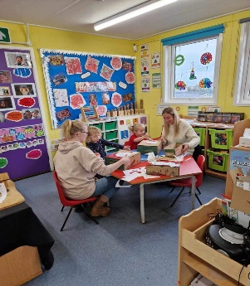
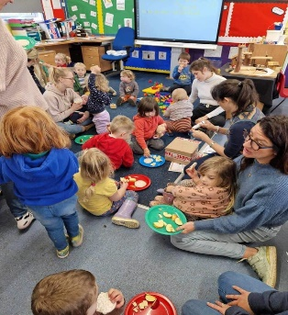

18 – Equal opportunities

Equal Opportunities Policy
The Early Years Alliance is committed to helping preschool provide equality of opportunity for all children and their families. As a member of the Alliance, Hoglets Pre-School works in accordance with the relevant legislation including:
- Disabled Persons Acts 1958, 1986
- Race Relations Act 1976
- Sex Discrimination Act 1986
- Children Act 1989
We believe that the activities within the setting should be open to all children and families, and to all adults committed to their welfare. We aim to ensure that all who wish to work or volunteer to help within our preschool have a chance to do so.

Admissions
The preschool is open to every family in the community and wider community. The system we operate for admission is as stated in our admissions policy. Families joining the preschool are made aware of equal opportunities policy.

Employment
The preschool will appoint the best person for each job and will treat all applicants for the jobs and all those appointed fairly. Commitment to implementing the settings equal opportunities policy will form part of the job description for all workers.

The Early Years Foundation Stage (EYFS)
All children will be respected and their individuality and potential recognised, valued and nurtured. Activities and the use of play equipment will offer children opportunities to develop in an environment free from prejudice and discrimination. Appropriate opportunities will be given to children to explore, acknowledge and value similarities ad differences between themselves and others.

19 – Festivals

Our aim is to show respectful awareness of all the major events in the lives of the families and children in the preschool, and in our community as a whole. We welcome the diversity of backgrounds from which we all come, and we celebrate British Values. In order to achieve this, we aim to acknowledge a range of the festivals which are celebrated in our community and by families within the preschool.
Without introduction to any specific faith, children will be aware of some of the festival that are being celebrated by their own families or by others around them. They will be introduced, where appropriate, to the stories behind festivals.
Before introducing a festival with which the adults in the preschool are unfamiliar, appropriate advice will be sought from people for whom that festival is a familiar one.
Children and families may celebrate festivals at home with which the rest of the group may not be familiar. They may be invited to share their festival with the rest of the group, should they wish to do so.

20 – Resources

British Values are embedded in everything we do, and resources will be chosen to give children a balanced view of the world and an appreciation of the rich diversity of our multi-racial society. Materials will be selected to help children develop their self-respect and to respect other people by avoiding stereotypes and derogatory picture messages about any group of people.

Special Educational Needs
The preschool recognises the range of special needs of children and families in the community and will consider what part it can play in the meeting those needs. Planning for preschool meetings and events will take into consideration the needs of people with disabilities.

Discriminatory Behaviour and Remarks
These are unacceptable in the preschool. The response will aim to be sensitive to the victim(s) and to help the perpetrator(s) to understand and overcome their prejudices. Abuse towards our staff will not be tolerated.

Language
Information, written and spoken, will be clearly communicated in as many languages as necessary. Bilingual/multilingual children are an asset. They will be valued, and their language recognised and accepted within the preschool.

Food
Medical, cultural and other dietary needs will be met.

We hope you and your child enjoy both of your journeys through Hoglets together.

